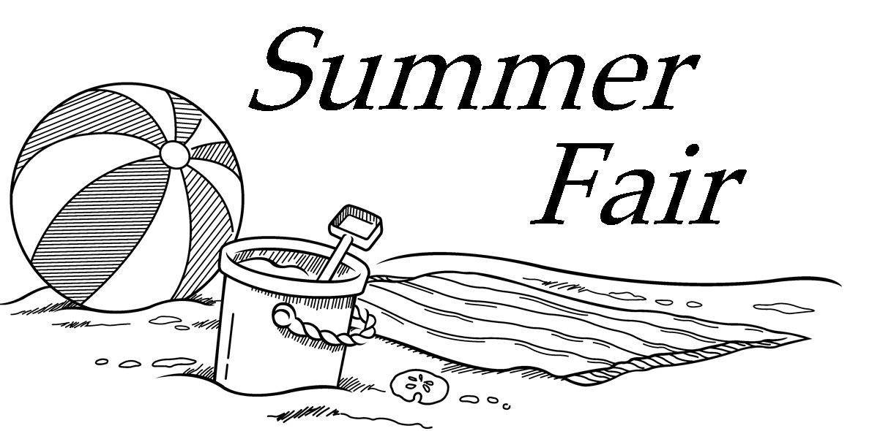

at the Lovell United Church of Christ
1174 Main St.
Lovell, ME

Thursday, August 3rd
10:00 – 1:00

Gifts, Baked Goods, Produce, Flowers, Balsam Fir Pillows, Jewelry, Treasures, Serrv Items, Raffle
and Lunch

